 | Assignment No. 02 (Graded)  SEMESTER Spring 2014  CS301- Data Structures |  | Total Marks: 20  Due Date: 27/05/2014
Instructions
Please read the following instructions carefully before solving & submitting assignment:
It should be clear that your assignment will not get any credit (zero marks) if:
- The assignment is submitted after due date.
- The submitted code does NOT compile.
- The submitted assignment file is other than .CPP format.
- The submitted assignment file does not open or corrupted.
- The assignment is copied (from other student or ditto copy from handouts or internet).

Uploading instructions
For clarity and simplicity, You are required to Upload/Submit only one .CPP file.
- Don’t wait for grace day. Grace Day is given only if there is problem with LMS on due date. Submit your solution within due date.
- Note that no assignment will be accepted through email if there is any problem on grace day.

Note: Use only Dev C++ IDE.

Objective
The objective of this assignment is to make you familiar with array, link list, stack and queue data structures and programming techniques related to them.

GOOD LUCK

 |  | Marks: 20
You got an internship in a game developing company. They gave you first task of developing a mini dice rolling game using data structures and C++ as programming language. Your game should meet the following requirements.

Requirements:
- Game should be build with the help of stack, link list, array and queue data structures.
- Game will prompt user to enter the number of players in game.
- Input the name of player and take 5 turns by rolling dice. Outcome of dice should be added into total scores of player.
- Save each player’s record into stack.
- Stack should be implemented using link list.
- Finally pop all player name and scores from stack and print them as summery.
- Use queue data structure as dice, having six values from 1-6. Queue should be implemented with the help of array (circular array).
- To randomly select the value from the queue, we will rotate a loop up to a random value(obtained with the help of built in method rand()

See the pictorial representation of problem given below.

Stack
Queue
rear
front
top

Solution Guidelines:
- Before developing this assignment understand and practice following topics (array, link list, stack implementation using link list and queue implementation using circular array).
- Use stack data structure to save information of players. Each player will represent a node which will contain player name and scores.
- Use queue data structure to save dice numbers and get random number from dice. Use circular array to implement queue.
- Your solution should use these classes
  - Player (Node) Class : To save information of each player
  - Stack Class: To save different players
  - Queue Class: To save dice numbers 1-6 and get random number from dice.
- Before calling rand() method use this line ( srand(static_cast<int>(time(0))); ) to get different random numbers.

Sample Output
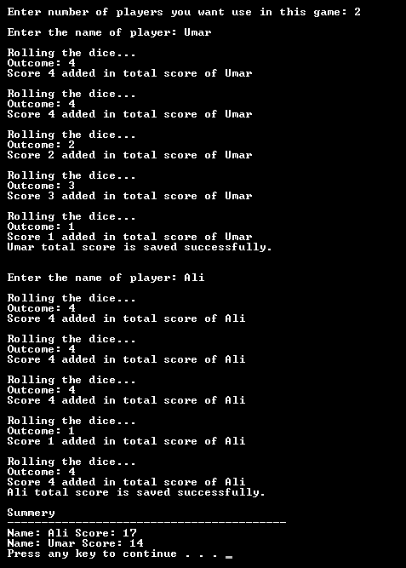

Lectures Covered: This assignment covers Lecture # 1-15
Deadline: Your assignment must be uploaded / submitted on / before, Tuesday, May 27, 2014.

